Day 8 - 104608492 - Shirisha Perapagu

Java Oops

Task 031

Wap to demonstrate inheritance

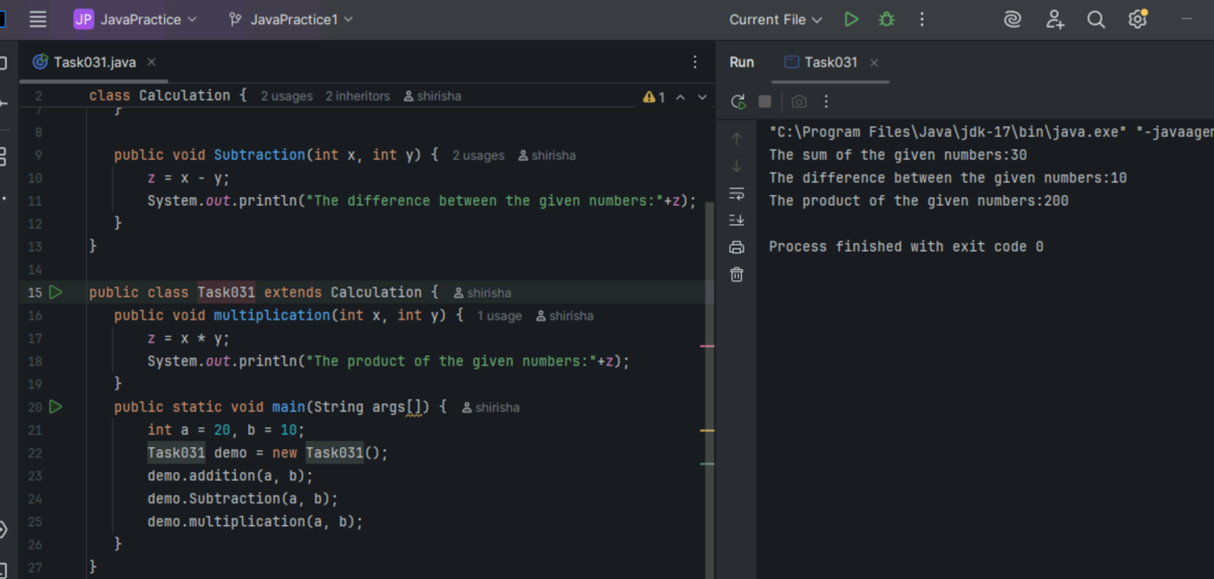

Task 032

Is multiple inheritance supported in java?

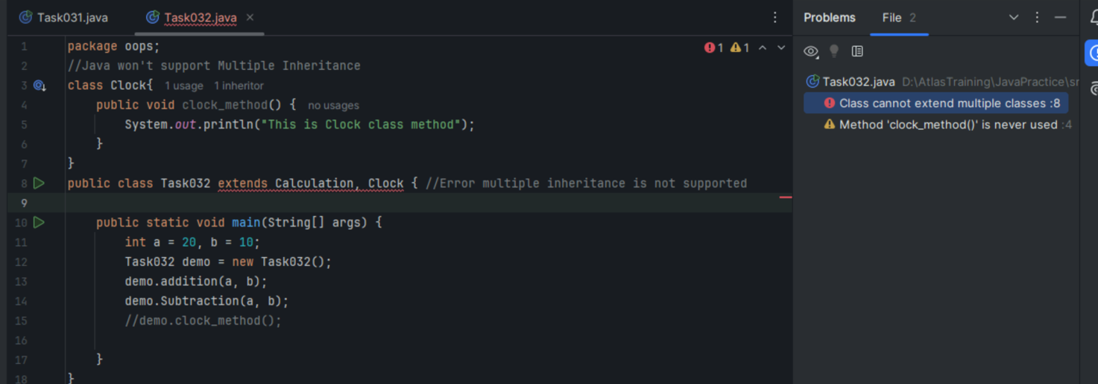

No Java doesn’t support Multiple Inheritance to avoid ambiguity and to avoid the diamond problem which arise when a class inherits from 2 classes which in turn inherits from a common superclass.

Task 033

Wap to demonstrate super keyword

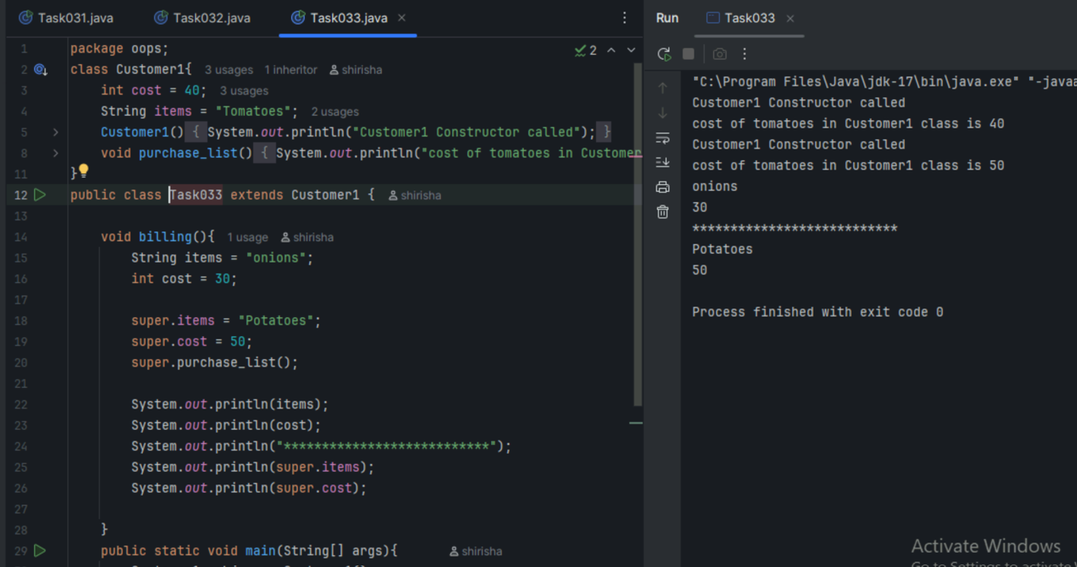

Task033_1

Wap to use super keyword to call parent class constructor

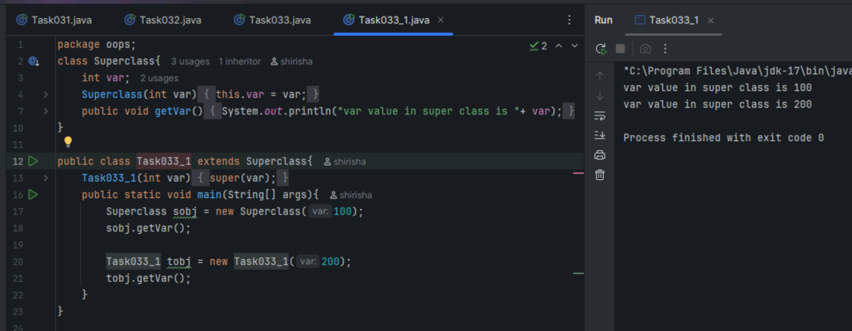

Task 034

Polymorphism - no. of parameters

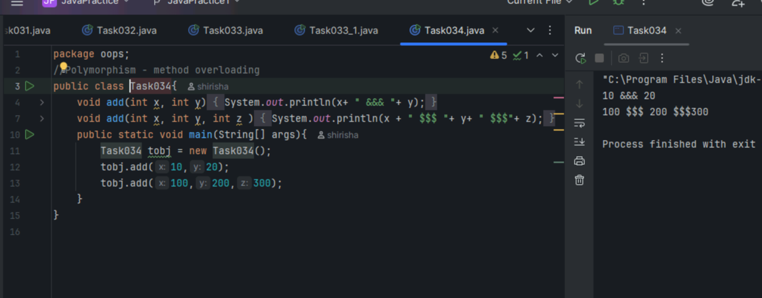

Task 035 - Polymorphism - type of parameters

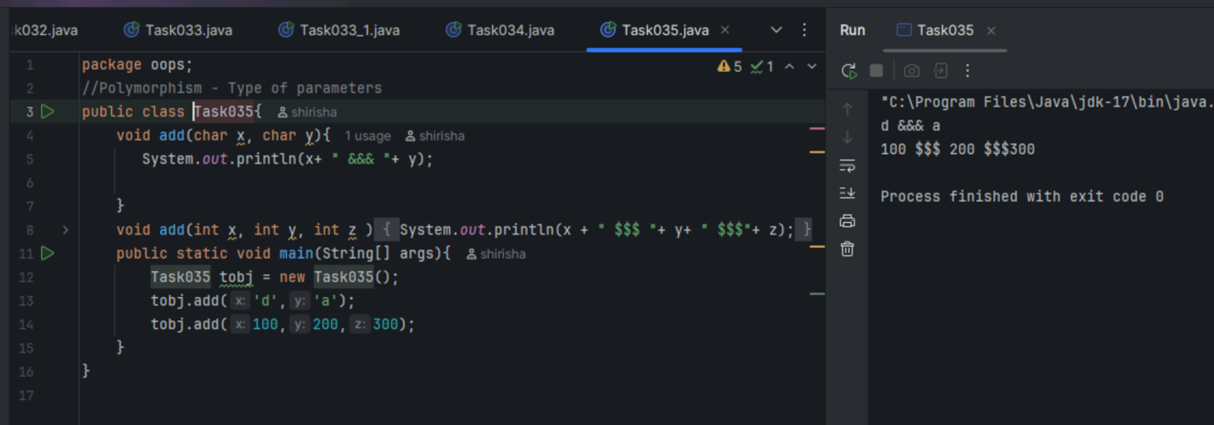

Task 036 – Polymorphism - sequence of parameters

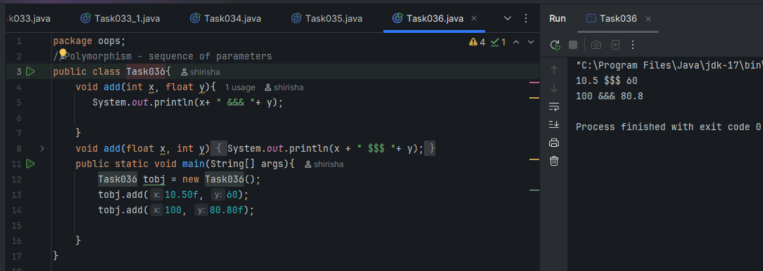

Task 037 - Encapsulation example

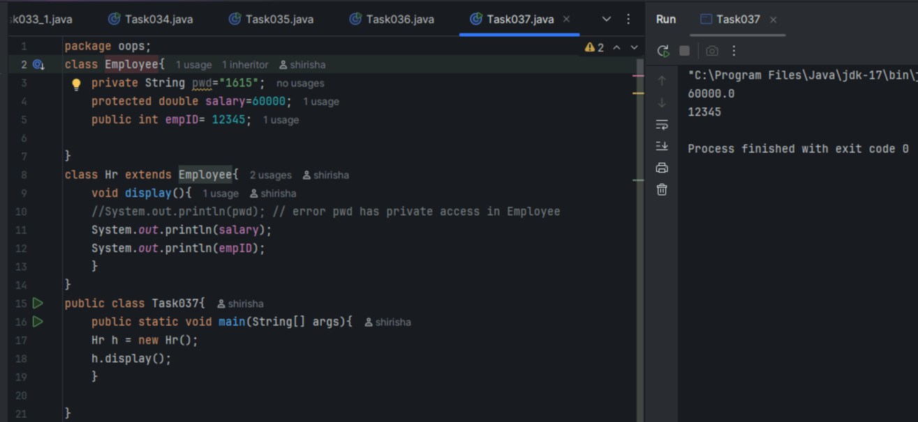

Task 038 – Abstraction error

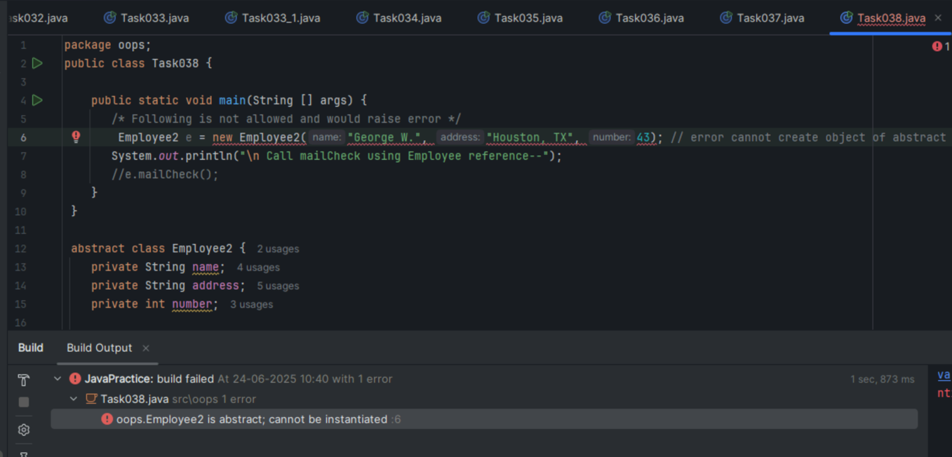

Task 039

Rewrite the above code to give output without errors

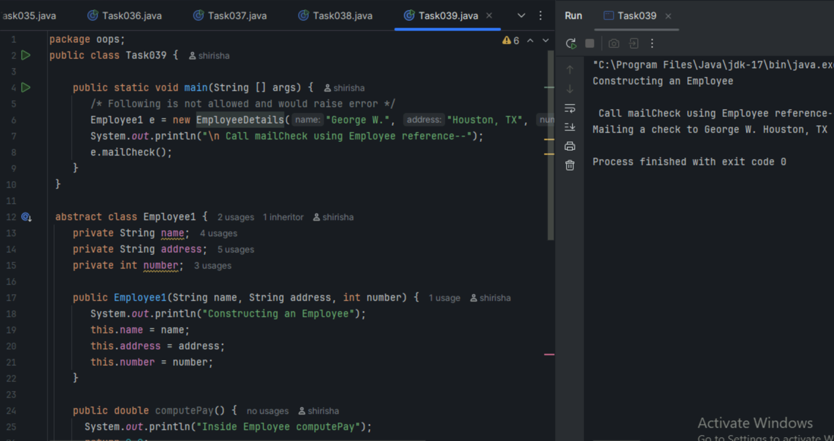

Task 040 – Working of Abstraction in Java

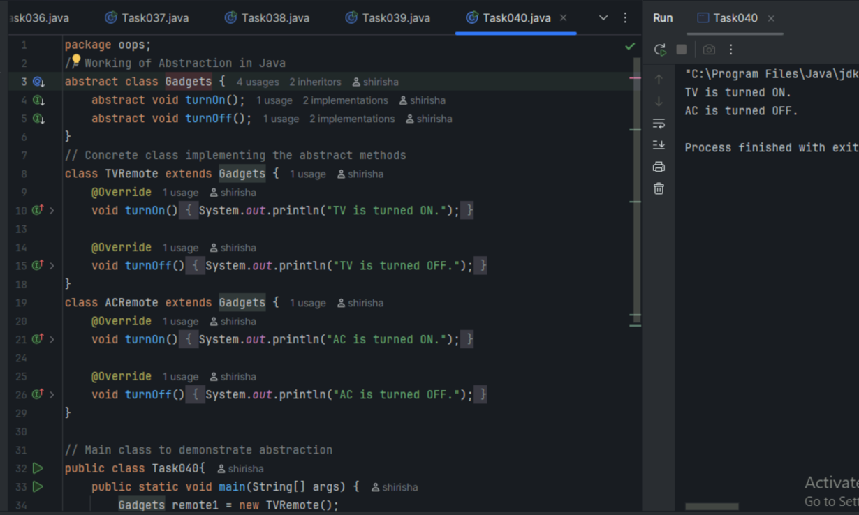

Task 041

Interface Implementation

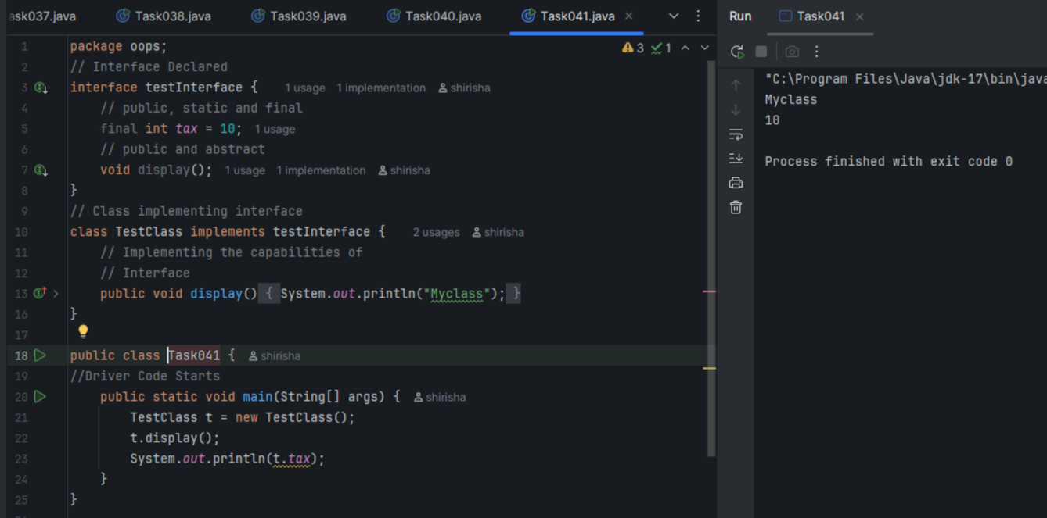

Task 042:

Difference between constant and final.

In java, final keyword is the way used to make constants i.e. unchangeable.

final keyword can be used with variable, method and class which prevents it from being changed.

If used with variable, it makes that variable constant i.e. it cannot be reassigned values.

If used with method, it cannot be overridden by subclass method.

If used with class, it cannot be inherited.

=====================================================================================

HOME TASKS 021 – 030

=====================================================================================

Task 021

Wap to initialize an array and traverse it using a for loop to print each element.

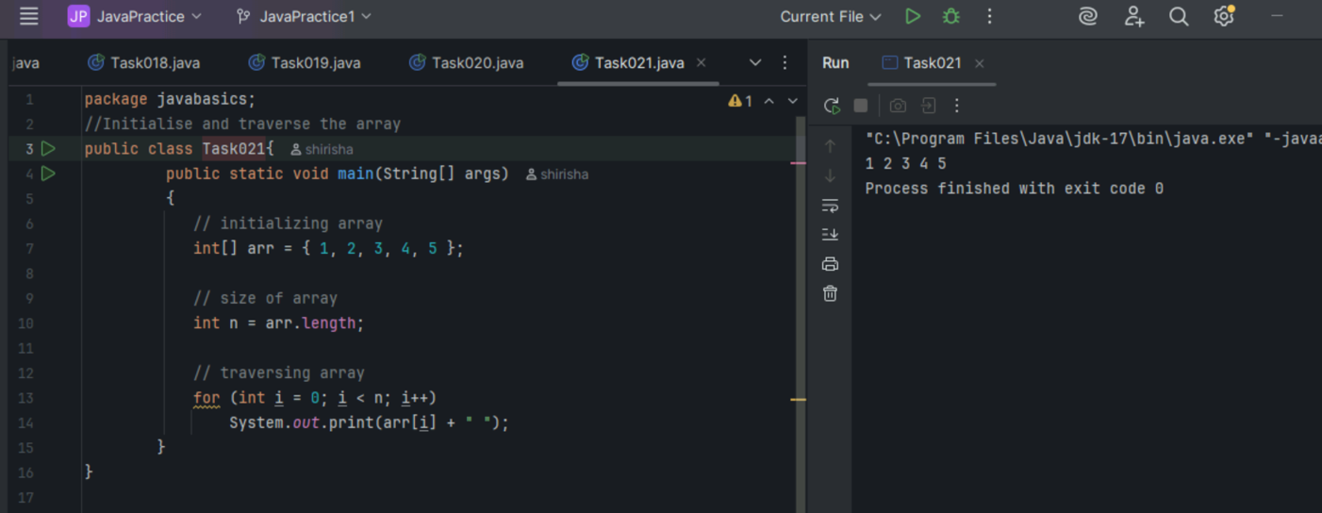

Task 022

Java program to illustrate creating an array of integers, put some values in the array and prints each value to standard output.

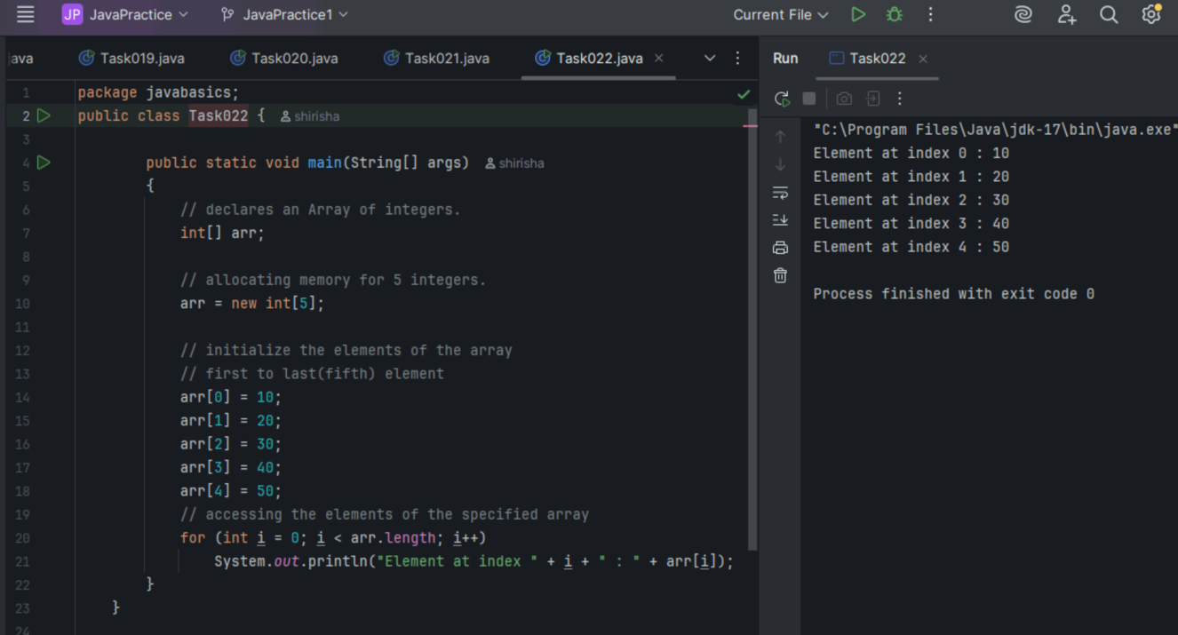

Task 023

**Example:** Here we are taking a student class and creating an array of Student with five Student objects stored in the array. The Student objects have to be instantiated using the constructor of the Student class, and their references should be assigned to the array elements.

Java program to illustrate creating an array of objects

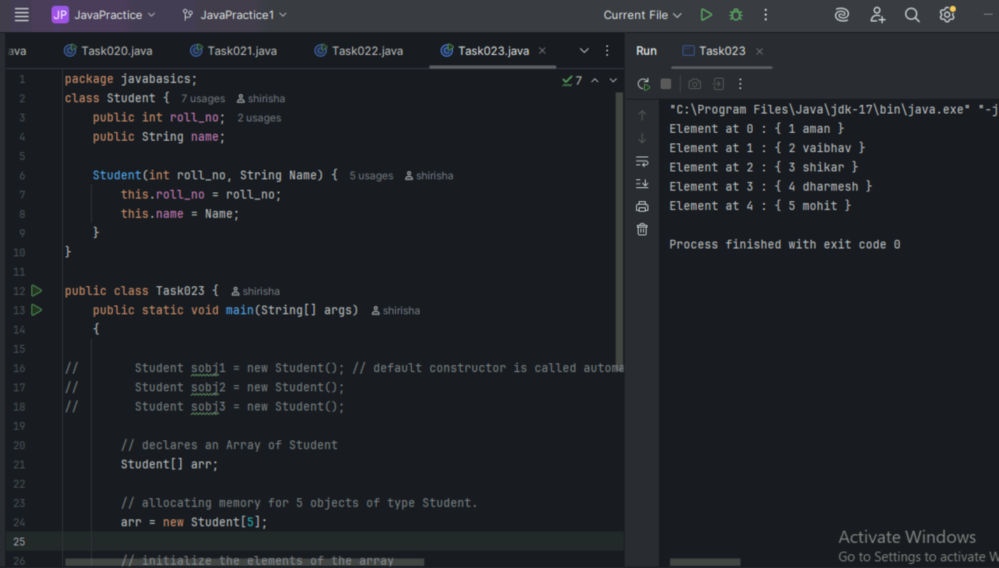

Task 024

Another way to create an array of objects

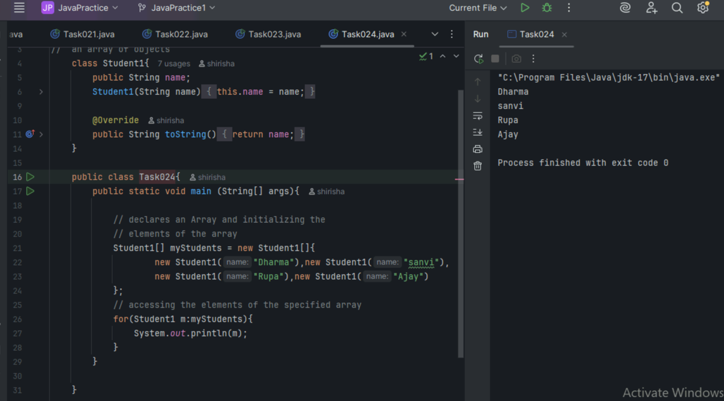

Task 025

Code for showing error "ArrayIndexOutOfBoundsException"

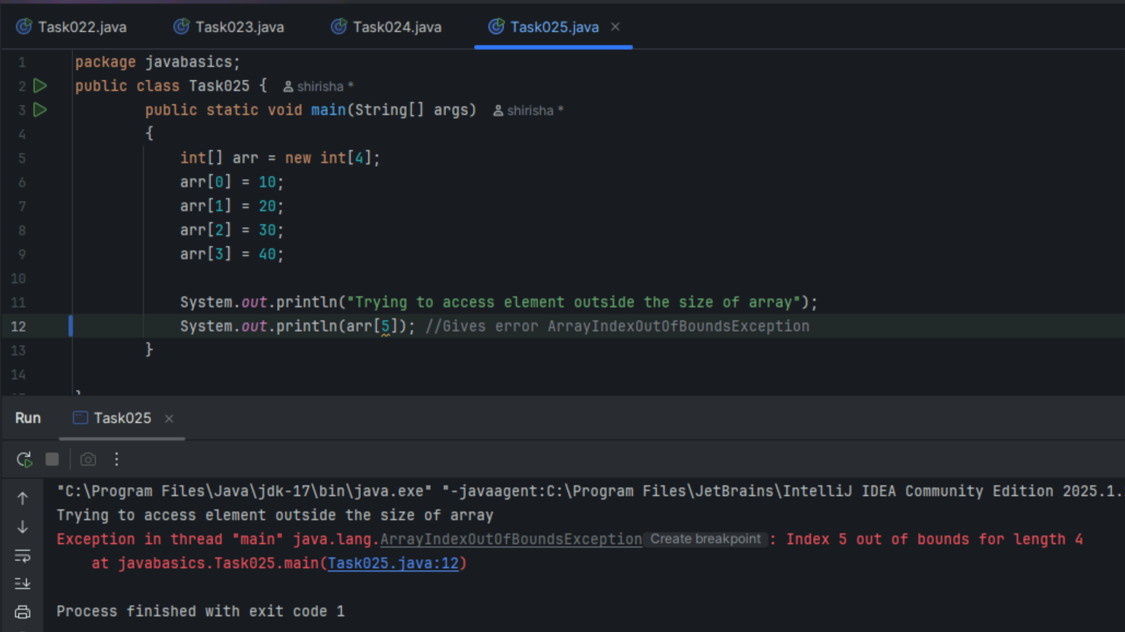

Task 026

Wap to demonstrate Multidimensional Array.

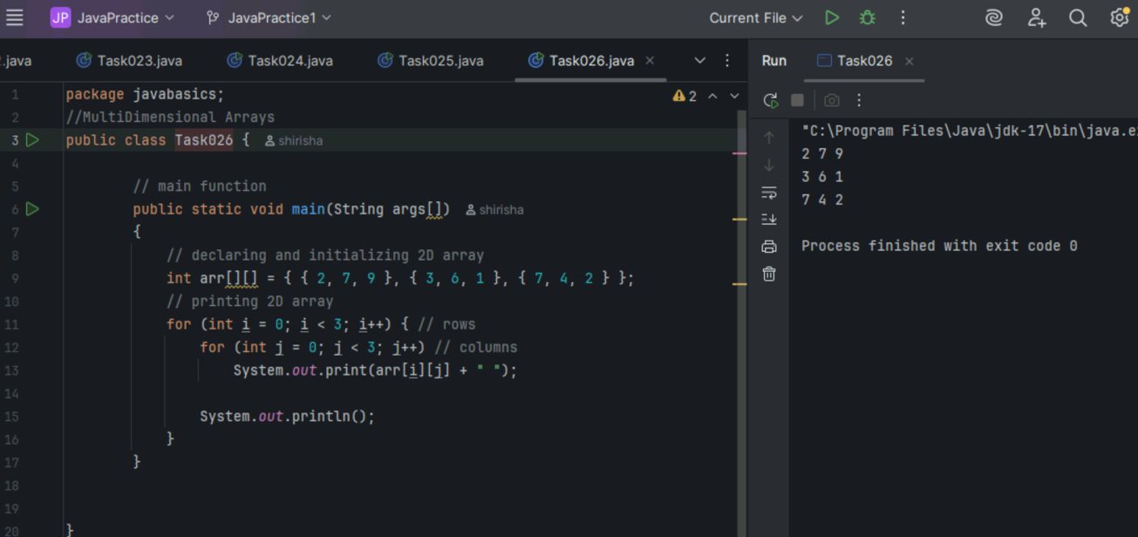

Task 027

Java program to demonstrate passing of array to method

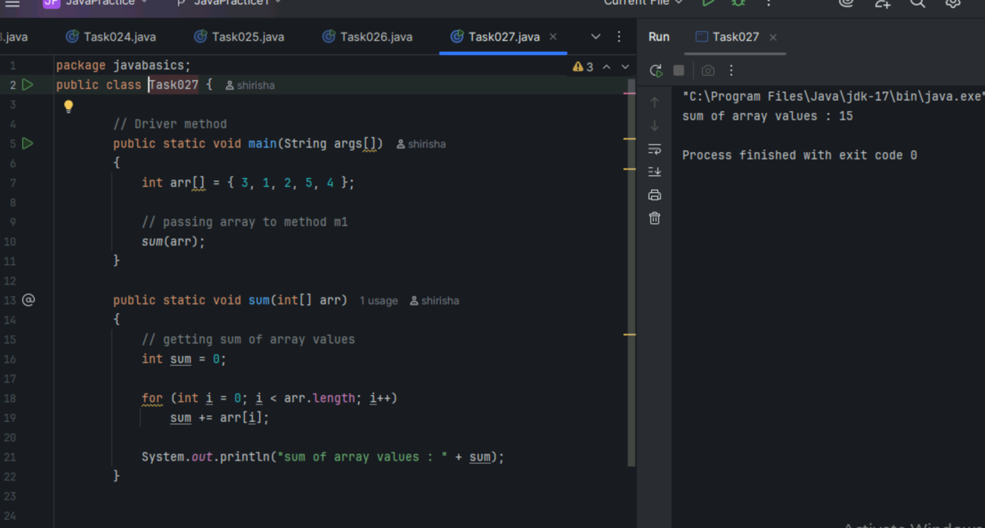

Task 028

Java program to demonstrate return of array from method

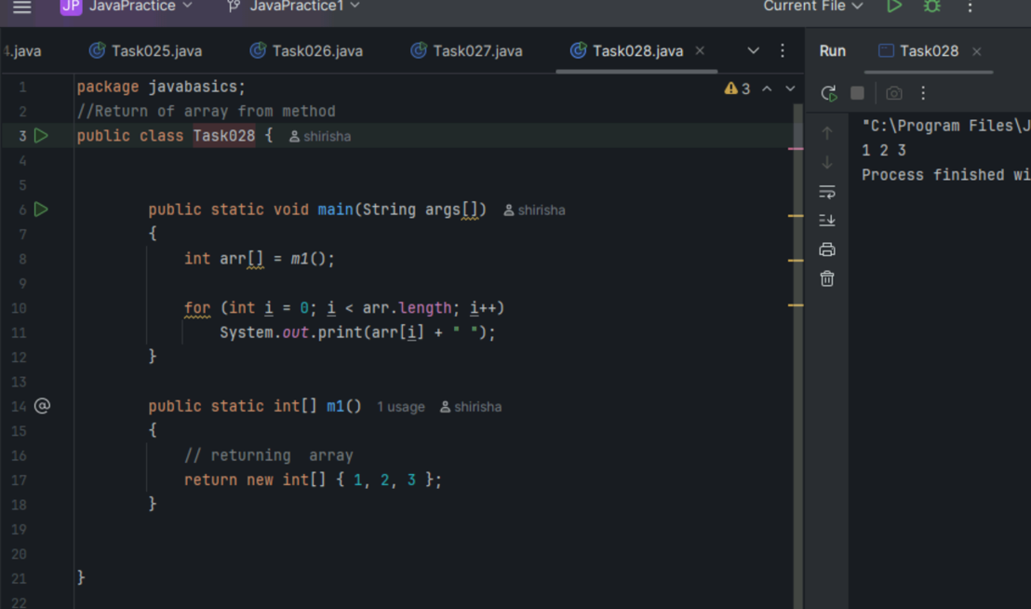

Task 029

Java program to demonstrate cloning of one-dimensional arrays

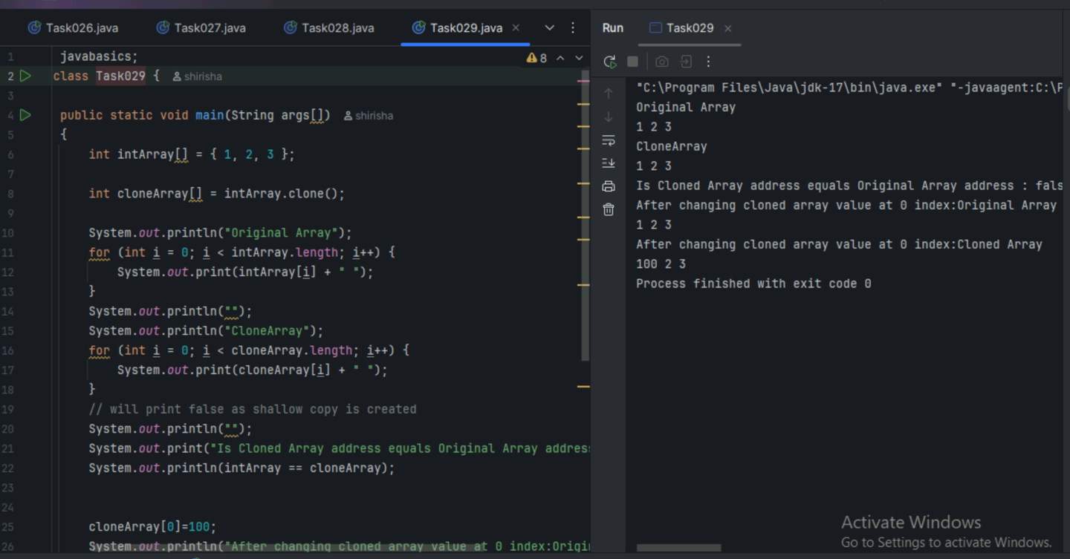

Task 030

Java program to demonstrate cloning of multi-dimensional arrays



